

**Risk, Uncertainty and Monetary Policy**

Speech given by

Charles Bean, Executive Director and Chief Economist of the Bank of England

To Dow Jones, at City Club, Old Broad Street 31 October 2007

1

All speeches are available online at [www.bankofengland.co.uk/publications/Pages/speeches/default.aspx](http://www.bankofengland.co.uk/publications/Pages/speeches/default.aspx)

Good evening! One of former US Secretary of Defence Donald Rumsfeld’s most noted musings runs thus:

“…as we know, there are known knowns; there are things we know we know. We also know there are known unknowns; that is to say we know there are some things we do not know.

But there are also unknown unknowns - the ones we don't know we don't know.” For this rumination, Rumsfeld was awarded a ‘Foot in Mouth’ award from the Plain English Campaign. But in truth, it represents one of the pithier encapsulations of the economists’ distinction between risk and uncertainty of which I am aware.

Risk applies to those random events to which one can attach probabilities, such as the number of times a fair coin comes up heads in 100 tosses. These are the ‘known unknowns’. In contrast, uncertainty – or more accurately Knightian uncertainty, after the Chicago economist Frank Knight

– applies to random events to which it is difficult to attach probabilities, say because we have no previous experience of them or do not understand enough about their nature. An example might be the number of coins in this building right now. These are the ‘unknown unknowns’. The Monetary Policy Committee faces both sorts of randomness when it sets interest rates each month. Tonight I want to discuss an example of each.

### Data uncertainty

My first example relates not to the future but to the past. Steering the economy has sometimes been likened to driving along a winding road looking only in the rear-view mirror. I wish it were that easy. In practice, the rear window is also a little misted up (the steering is also pretty wobbly, but that is for another day). Not only do we not know where we are going, but we have only an imperfect idea of where we have been.

Our primary signposts are, of course, provided by the Office for National Statistics. But the slew of macroeconomic indicators that we review each month ahead of our policy decision typically provides only an imperfect guide to the underlying reality. There are a couple of reasons for this. First, it may be intrinsically difficult correctly to define or measure economic concepts such as value added in the financial sector or the user cost of owner-occupied housing. In that case, the ONS has to employ a variety of proxy variables instead. Second, even if a concept can in principle be measured, there may nevertheless be significant sampling error. However, if more information accrues over time, then the data can be revised in the light of that new information and the measurement error will tend to shrink.

That much official data are revised is clearly not in itself a cause for concern. The MPC would clearly not want to wait until all the information is in and reconciled before receiving any official data – that would mean, for instance, the first GDP estimates appearing well after the fact. Far better that we receive timely, albeit inaccurate, initial estimates to factor into our decisions. But we do need to recognise that such early estimates may be revised in framing our interest rate decisions.

Given the extensive revision history of many of the key variables, it is reasonable to try to form a judgement about the distribution of eventual data outturns. To accord with my earlier classification, we perhaps ought to call this ‘data risk’. However, the term ‘data uncertainty’ is now well established in the literature, so I shall retain it here.

To see why data uncertainty might matter, first look at Chart 1. This plots the initial and current official estimates of four-quarter UK GDP growth, as well as the range of the intervening estimates. It is apparent that the mature data occasionally looks quite different to that provided by the initial estimates. For instance, the initial estimates suggested a sharp slowdown in 1998 in the wake of the Asia and Long-Term Capital Management crises, whereas the current estimates suggest that the pace of expansion barely eased at all. For more recent quarters, the initial and current estimates are closer together, but that may simply reflect the comparative youth of the latest estimates, as well as the fact that the 2007 *Blue Book* did not involve a full balancing of the National Accounts.

Such discrepancies would be unimportant if they did not potentially translate into significant policy differences. But the differences between initial and mature estimates can be large enough to matter. For instance, if we employ a simple ‘Taylor Rule’ to evaluate policy using a ‘real-time’ measure of the output gap based on the initial data and on a measure based on the mature data, the difference quite often exceeds 50 basis points (though some of that is down to the difficulties of identifying potential output in real time)1. The presence of such measurement error therefore provides a reason for rational policy makers to partially discount early estimates of variables like GDP, particularly if they seem at odds with other indicators, for instance from business surveys.

1 The US economist John Taylor found that Federal Reserve policy could be roughly described by an interest rate

reaction function in which the deviation of the policy rate from its long-run or neutral level was equal to half the output gap plus half the deviation of inflation from its target level. For the initial estimates of GDP, the output gap is computed by taking the deviation of those initial estimates from a measure of potential output obtained by applying a Hodrick-Prescott filter to the latest release then available of the previous 20 years of data. For the mature data, potential output is computed by HP-filtering the data in the most recent release.

In dealing with such data uncertainty, the policy maker is essentially faced with a set of ‘signals’ of the underlying state of the economy that are contaminated by ‘noise’ in the shape of measurement error. What the policy maker needs to do, therefore, is extract an estimate of these underlying signals. For some time now, Bank staff have been developing the tools to do this. Our initial work used simple regression analysis to forecast what the mature estimates would look like based on their past relationship with early estimates and with other indicators, for instance from business surveys. That approach has been used for some time to help the Committee form its judgements about the conjuncture and about the prospects for growth and inflation.

Recently, we have completed a substantial project that applies more powerful techniques2. First, the approach allows for richer and more realistic models of the data revision process. For instance, for some series, revisions may typically result in significant changes in the quarterly profile with less noticeable changes to the corresponding annual figure; the new approach allows for this interdependence. And as the ONS improves its measurement capability, so revisions should tend to become smaller in absolute magnitude; if we know this, then the new approach can allow for it too.

Second, as in our earlier work, other information – for instance from business surveys or the Bank’s regional Agents – can be introduced. But in addition the methods can exploit information in variables that are only indirectly related. For instance, output is by definition equal to the sum of the expenditure components, and this accounting identity should hold not only in the original noisy data but also in any estimates that are purged of that noise. A similar argument applies to the identity relating nominal spending, real spending and the associated price deflator.

In past *Inflation Reports*, the fan chart showing the Committee’s best collective judgement for the outlook for GDP was drawn using the latest vintage of ONS data for the past, even though the Committee sometimes indicated that it thought the data were more likely to be revised in one direction or the other. Exceptionally, in our August *Inflation Report* this year, we also included a second fan chart drawn conditional on an alternative path for the past data, derived using our (earlier) toolkit for handling data uncertainty.

In the future, in order to enhance transparency, the Committee intends to provide its growth projections in a fashion that reveals its best collective judgement of the past, as well as future prospects. In other words, it will provide a ‘backcast’ as well as a forecast. However, just as the

2 Specifically using the Kalman filter. See Alastair Cunningham and Christopher Jeffrey, ‘Extracting a better signal

from uncertain data’, *Bank of England Quarterly Bulletin*, 2007 Q3.

forecasts describe an uncertain outlook, so too do the backcasts as the future course of revisions is unknown. So the fan will henceforth extend backwards as well as forwards.

Chart 2 provides an example of what the fan chart will look like. This assumes the same projection for quarterly growth over the future as in our August projections, but uses our new technology to generate mechanically a probability distribution for the back data as well. For the past, the centre of the darkest band of the fan reflects an assessment of the most likely path for four-quarter GDP growth once the revisions process is complete. The fan around this path describes the degree of uncertainty around this path, while the width of the fan – which covers 90% of the distribution – is calibrated using historical information on data revisions. The fan becomes progressively narrower the further back in time one goes, reflecting the decreased incidence of revisions for more distant periods. In practice, the distribution for the back data need not be generated mechanically and, like the forecast, will be subject to the Committee’s judgement. For instance, the statistical modernisation program currently being undertaken by the ONS should lead to more accurate early estimates of growth and we will want to take this into account by narrowing the fan accordingly.

The current vintage of official GDP growth data is shown by the black line. For the most recent period, the most likely path for the mature estimates of growth lies above the current vintage of data, reflecting the fact that other indicators and the past history of revisions suggest that recent official estimates are somewhat more likely to be revised up than down. But the width of the fan is considerable, serving to emphasise the significant degree of uncertainty about the past faced by the Committee.

The MPC’s projection for the quarterly growth of GDP over the future is the same as in the August *Report*, so the fan looking forward looks rather similar to the one we published then. There are, however, a couple of minor points of note that arise from the appearance of the quarterly growth rates over the past year in the calculation of the projected four-quarter growth rates over the first year of the forecast. First, the four-quarter growth rates in the first year of the projection are now expressed taking on board the Bank’s assessment of the most likely path for GDP in the recent past, rather than the current vintage of official data That means care will be necessary in making any comparisons either with current estimates of the data or with the projections of other forecasters.

Second, the fan is a little narrower during the first year of the forecast, as the central estimate of growth over the recent past should be less prone to revision than the official estimate itself.

All this relates to the Committee’s projections for GDP. The presentation of the CPI projections will not change as the data for CPI are almost never revised and the official statistic for CPI inflation represents our target measure.

In concluding this part of my discussion, let me note that some recent media commentary has described our work on data uncertainty as indicating a loss of faith by the Bank in the ONS, which has led us to start producing our own independent estimates of key macroeconomic indicators. This represents a major misunderstanding of our respective roles and of the aims of our data uncertainty work. The ONS’s task is primarily one of *measurement*. This is a particularly difficult task in an evolving economy and one that they execute outstandingly well. Moreover, the data produced by the ONS represents far and away the single most important source of information for us. But we do know that early official estimates are affected by unavoidable measurement error and therefore need to be *interpreted* in the light of our economic understanding and other available sources of information. Just as we do not have the resources to get into serious measurement of the wide range of variables we care about, so it would be inappropriate for the ONS to stray too far from measurement into interpretation. This just represents a natural division of labour between the two of us.

### The implications of the recent developments in financial markets

Let me now turn to a case where it is presently particularly difficult to form a view about the distribution of outcomes – Rumsfeld’s ‘unknown unknowns’, if you like. That is the impact on the economy of the recent turmoil in credit and money markets.

Now episodes of financial market turmoil do occur from time to time and often share common features, such as a period of over-exuberance leading to asset price appreciation and increased leverage, followed by a retrenchment as asset prices fall back. And maturity mismatches between assets and liabilities often make an appearance when banking systems come under strain. But even so, each episode tends to unfold in a unique fashion, making it harder to predict the macroeconomic consequences.

The latest episode contains some such features, though the disruption it has wrought on some of the largest and most liquid markets in the world has been exceptional. We and other central banks had warned about the risk of a sharp unwinding of the compression in risk premia across a range of assets that had occurred over the past three years, and the potential risks to institutions with a

growing dependency on wholesale funding markets of impaired market liquidity. But I do not think anyone quite foresaw the chain of events that would take place. To begin with, a further rise in defaults in a sub-sector of the US mortgage market prompted a general loss of confidence in asset- backed securities and other structured credit instruments, including those based on unrelated markets. Investment vehicles with exposures to these assets found it much harder to fund themselves in asset-backed commercial paper markets. These events led to a seizure of international money markets as banks hoarded liquidity in the face of a reduced ability to continue securitising loans and the potential activation of credit lines to their off-balance sheet vehicles. Our latest *Financial Stability Report* explores these events in some detail and I do not propose to add to what is said there.

Instead, I want to consider the possible macroeconomic consequences of recent events. First, the good news is that there have been signs that conditions in some markets have been improving.

Investors appear to be becoming more discriminating across different classes of securities, with more trade taking place, particularly in prime vanilla mortgage-backed securities. Asset-backed commercial paper spreads have fallen back from peaks in September. In the money markets, the excess of term US and UK interbank rates over measures of expected policy rates, though still elevated, are well below their early-September peaks (Chart 3). And the round of third-quarter earnings announcements by the major financial institutions has also revealed something about the distribution of losses across institutions. But it is likely to be a while before the valuation of the more complex securities is clarified and the financial markets return to normality. In the mean time, they remain vulnerable to further shocks.

So what does all this mean for the real economy? Could we be heading for a significant slowdown? First, I should note that both the world and UK economies start from a strong position. While the US economy has already slowed on the back of falling house prices and weak residential investment, that has not so far significantly affected consumer spending and non-residential business investment. In the euro area, growth has been somewhat faster than trend over much of the past year, though there are signs that the pace of expansion has eased a little latterly. And Asia, led by China, has continued to grow rapidly.

Here in the UK, according to the official estimates, we have seen seven consecutive quarters of growth in the range 0.7% to 0.8% and, in line with Chart 2 above, the Committee judges that actual growth is, if anything, likely to have been slightly stronger. It is true that CPI inflation at 1.8% is now just a little below our target 2%. But even so, we cannot afford to relax on the inflation front.

Business surveys suggest that the margin of spare capacity is relatively limited and that firms are finding it a bit easier to make price increases stick. The price of oil has just exceeded $90 per barrel and other commodity prices, especially food, have been rising strongly. Moreover, the best of the beneficial ‘tailwind’ afforded by off-shoring and outsourcing to China and the other emerging economies is probably behind us now.

Against that background, the Committee thought in August that some slowing in UK growth was probably necessary to keep inflation on track to meet the target in the medium term. And at least some of that slowing was probably already in the pipeline before the onset of the turmoil in financial markets as a result of the earlier increases in Bank Rate.

The recent developments in financial markets are likely to have led to a softening in the outlook for growth. There are a number of ways the quantity and/or price of credit supplied to households and businesses may be adversely affected. First, banks find themselves no longer able to securitise loans as expected and anticipate having to fund committed credit lines to conduits. That will reduce the supply of funds for new loans. But the investor funds that are not used to purchase mortgage- backed securities and asset-backed commercial paper have to go somewhere else instead, so some of the funds that have been lost may find their way back into the banking sector.

Second, even if the funds do find their way back, they will not necessarily go to the same banks. In normal times, the interbank market redistributes funds within the sector at low cost. But in present circumstances that cost is elevated and some loan rates will reflect that. However, this should be a temporary effect that will only last as long as the dislocation in money markets persists. Moreover, it should be noted that, beyond the very near term, the rise in term interbank premia has already been largely offset by a decline in risk-free market interest rates as market participants anticipate a more accommodating monetary policy stance.

Third, looking to the longer run, it is unclear how banks will respond to the weaknesses in the ‘originate and distribute’ model that have been revealed by recent events. Some of the compression in risk premia over the past three years will have reflected the onward distribution of risks by banks which have been adopting this model. If that no longer takes place to the same extent and the risks instead remain on banks’ balance sheets, then the rates charged to borrowers will rise. Moreover, there are already signs that some lenders are exiting the riskier segments of the credit market. That will lead to a reduction in competition and a rise in interest rates charged, particularly to less credit- worthy borrowers.

Fourth, if banks are forced to take loans back onto their balance sheets from conduits, then their capital ratios will, other things equal, deteriorate. British banks are generally well capitalised and hold well above regulatory minima – quite enough to cover all the loans that might come back onto their balance sheets (Chart 4). But that said, banks may be unwilling to tolerate that much erosion of their capital buffers because of the impact it would have on their ratings and their ability to raise funds. So this ‘bank capital’ channel may also lead to a reduction in the supply of credit.

Fifth, the quantity of credit advanced to a borrower and the interest rate charged thereon is frequently related to the value of the available collateral. Past episodes of significant contractions in activity in the wake of financial market turmoil have often been driven by falling asset prices and the sharp deterioration in net worth associated with highly leveraged portfolios. So far most asset prices have held up. After an initial hiccup in midsummer, equity prices have been buoyant, despite the heightened concerns about growth prospects (Chart 5). That could reflect the expectation that the US Federal Reserve and other central banks will lower policy rates enough to maintain a reasonable rate of growth. But commercial property price inflation has slowed sharply. And though house prices have so far broadly held up, some of the forward-looking indicators point to a weaker outlook. If equity or property prices were to fall significantly, then that would probably affect both the quantity of credit advanced and its price.

The complexity of the channels makes it difficult to judge the likely magnitude of the reduction in the supply of credit. For that reason, the information from the Bank’s new quarterly survey of lenders could prove valuable. The results for the third quarter suggested little prospective tightening in conditions to households (Chart 6) and, consistent with that, lending to individuals remained buoyant in September. However, loan approvals did fall back and anecdotal evidence suggests that some lenders at least are in the process of tightening standards on secured lending.

The credit conditions survey did suggest that some deterioration in the availability of credit to businesses was in prospect (Chart 7). However, banks are likely to focus on cutting back on the riskier forms of lending, including for mergers and acquisitions and leveraged buy-outs. The bulk of lending for fixed capital formation – which is what matters most for growth prospects – is perhaps likely to be affected less.

Changes in the supply of credit are not the only thing that matters, as the impact on spending also depends on the availability of alternative sources of finance. In particular, larger companies can

borrow on the corporate bond markets or raise equity. While the required rate of return on sub- investment grade bonds has risen, that on investment-grade bonds is little changed since early August (Chart 8). And so long as equity markets remain buoyant, equity finance also looks an attractive alternative option.

Finally, recent developments in financial markets may directly affect the expectations and behaviour of households and businesses. Any anticipated reduction in access to consumer debt will encourage households to increase their precautionary saving. And any anticipation of lower demand growth may lead businesses to put off investment or hiring. Although most indicators remained fairly strong in the latest CBI Industrial Trends survey, business optimism did slip which might presage such an effect.

Overall, it is difficult to assess with any degree of precision the impact on the economy of the recent developments in financial markets. That impact could be quite mild but it is also possible to envisage a sequence of events that generate a greater or more prolonged contractionary impact, particularly if some of the risks to the financial markets discussed in our latest *Financial Stability Report* were to crystallise. So this is one of the key ‘unknown unknowns’ that face us at the current juncture.

Policymakers lie awake at night worrying about both the ‘known unknowns’ and the ‘unknown unknowns’. There are plenty of both around right know. But there is at least one ‘known known’ that you should take away from my address tonight: the MPC’s absolute commitment to doing its best to meet the Chancellor’s 2% inflation target. And doing that is the best contribution we can make to the UK’s economic stability. Thank you!

Chart 1: Initial and current estimates of GDP

# Percentage change on previous year 6

**Earliest**

**Range**

**Latest**

**Latest available BB2 data**

5

4

3

2

1

0

1993 1995 1997 1999 2001 2003 2005 2007

Chart 2: August 2007 *Inflation Report* GDP projection with ‘backcast’

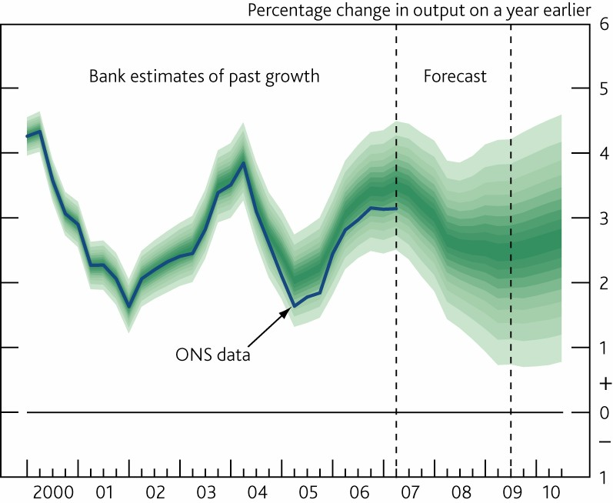

Chart 3: Premium of term inter-bank interest rates over expected policy rates

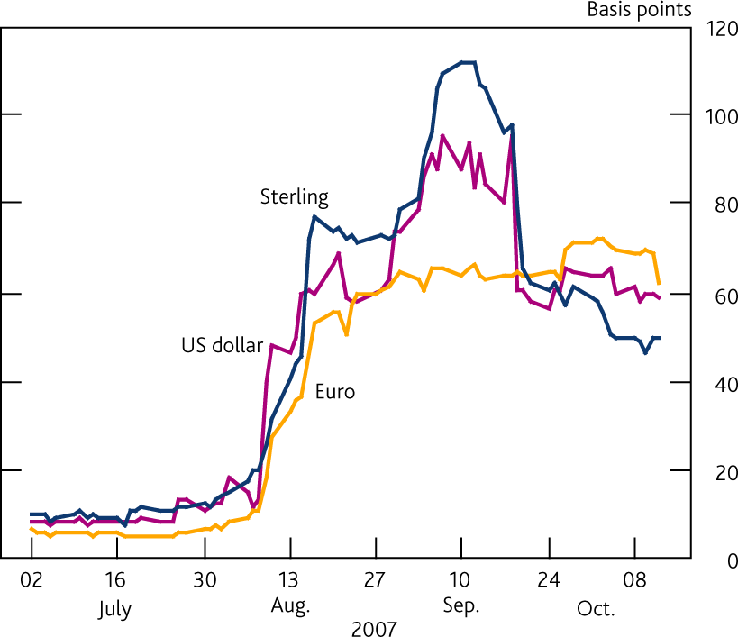

Chart 4: Major UK banks’ Tier 1 capital ratios

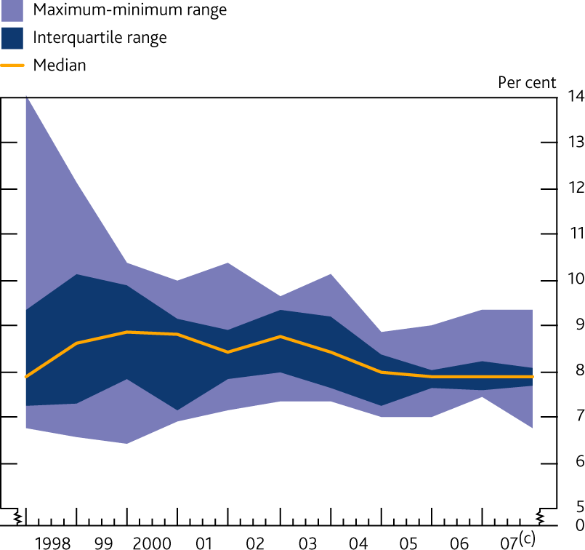

Chart 5: Cumulative changes in equity prices since January 2006

## Euro Stoxx S&P 500

FTSE All-Share Topix

Per cent

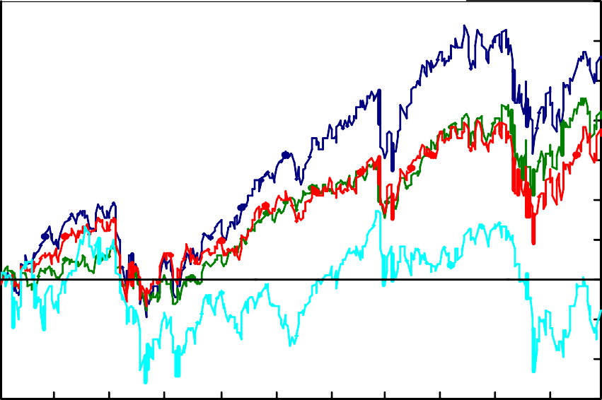35

30

25

20

15

10

5

0

-5

-10

-15

Jan Mar May Jul Sep Nov Jan Mar May Jul Sep 2006 2007

Chart 6: Credit conditions survey for households: secured credit availability

ances 60

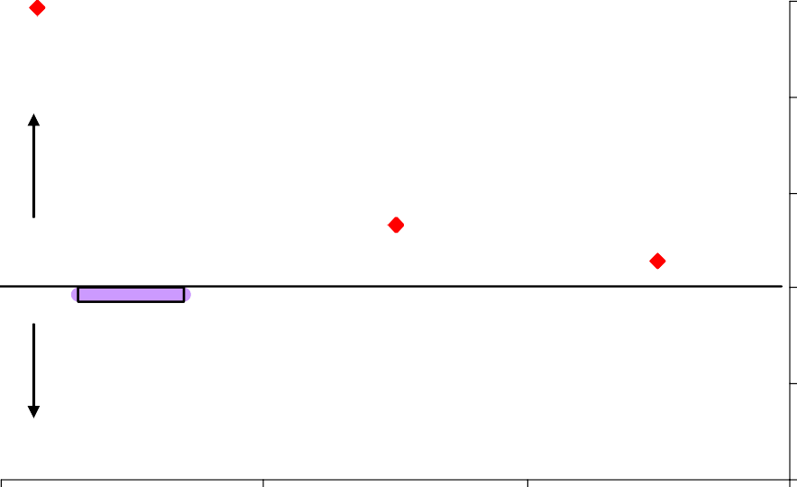

Perceptions over the past three months

Expectations over the next three months

Net percentage bal

More credit available

Less credit available

40

20

0

-20

-40

07q2 07q3 07q4

Chart 7: Credit conditions survey for businesses: overall credit availability

Perceptions over the past three months Expectations over the next three months



Net percentage balances

60

40

More credit available 20

0

-20

Less credit available -40

-60

-80

07q2 07q3 07q4

Chart 8: Corporate bond rates

Per cent

12

Non-investment

grade yield

Investment grade yield

August *Report*

10

8

6

4

2

0

Jan 06 Jul 06 Jan 07 Jul 07